Michael Weaver, Caleb Miller, Mathew Paschall

CST – 235

Brandon Bass

12/24/17

**CLC 7**

GitHub Link: https://github.com/battousairurik/CST-235

**CLC Questions**

1. ProgrammableWeb.com contains several API, or application programming interfaces, many of which operate the same way. One such program is the Unofficial Pokémon Go java API, which allow you to create your own interactive player portal for the Pokémon Go game.

***Pokemon Go API Location****: https://www.programmableweb.com/api/unofficial-pokemongo-java*

This package includes a GitHub link to the files for download and the API endpoint location for your designed application to link to. The files are located here:

***Pokémon Go GitHub Location****: https://github.com/Grover-c13/PokeGOAPI-Java*

The files include a ReadMe meant to describe how to install the folder and extract the data, but it is not detailed enough to actually work. Each of the provided files are structured to open a link to the Pokémon Go API then send or receive information over that open link. This is the way API function, so long as the data intending to be set is formatted correctly, the API will function. One such example is the CheckEvolutionExample.java which checks the current Pokémon id against the database to determine if there are any evolutions for the selected Pokémon.

1. **Describe 3 potential security vulnerabilities of web services. Substantiate your answer with code examples and screenshots of execution.** Buffer Overflow is a denial of service, data corruptor, and malicious code executer. An attacker can craft XML data causing the XML to call upon itself repetitively therefore constantly increasing in size. This causes a memory overflow, or trigger error messages which reveal information about the application. A DOS attack can be caused by forcing a server to parse an abnormally long XML file, which in essence uses up much more resources then actually generating one, and can crash the application. Another type of attack consists of sending a block of data to an application, which is stored in a buffer of insufficient size. This block of data can then overwrite genuine data and cause a function return which gives control to the malicious code in the hacker’s data block.
2. public class Overflow
3. {
4. public static void main(String[] args)
5. {
6. int importantData =1;
7. int[] buffer = new int[10];
8. for (int i =0; i < 15; i++)
9. buffer[i] = 7;
10. System.out.println("after buffer overflow ");
11. System.out.println("Important data = "+importantData);
12. }
13. }

*The buffer in the above example is 10 but the program is trying to write 15 resulting in a buffer overflow.*

XML Injection effects command execution, data can be stolen or deleted, and schema poisoning. QL Injection is a high-risk exploit which may be performed using SOAP messages. If a server does not validate data correctly, a SOAP message can easily be used to create XML data which inserts a parameter into an SQL query and have the server execute it with the rights of the Web Service. SQL Injection is only one of the threats a server is exposed to if data is not validated. A schema file is what an XML parser uses to understand the XML’s grammar and structure, and contains essential pre-processor instructions. An attacker may damage the XML schema or replace it with a modified one which would then allow the parser to process malicious SOAP messages and specially crafted XML files to inject OS commands on the server or database.

<?xml version="1.0" encoding="ISO-8859-1"?>

<users>

<user>

<uname>joepublic</uname>

<pwd>r3g</pwd>

<uid>0<uid/>

<mail>joepublic@example1.com</mail>

</user>

<user>

<uname>janedoe</uname>

<pwd>an0n</pwd>

<uid>500<uid/>

<mail>janedoe@example2.com</mail>

</user>

</users>

**Assignment Approach**

1. For this assignment I researched what API are, then utilized the provided links on the API homepage to locate the GitHub documentation for the Pokémon Go API. The GitHub page contains instructions, albeit incomplete, on how to unpackage the PokeGOAPI-Java. The provided description is not detailed enough for someone with only a small amount of programming knowledge to unpackage and use:

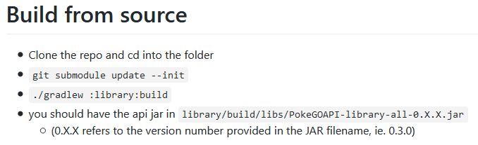

**List of Classes, Methods, Variables, etc.**

1. All public example code located in the GitHub link

**Screenshots**

Pokemon Go Evolution Check

